`

**GAS LEAKAGE ALERT SYSTEM WITH EXHAUST FAN**

**k.NEHA (21J41A66F3)**

**S.ARCHITHA (21J41A66J5)**

**M.VARSHA REDDY (21J41A66G8)**

**S.SAAKETH (21J41A66J6)**

**D.SAI TEJA (21J41A66E3)**

**CONTENTS**

INTRODUCTION

PROBLEM

SOLUTION

DESCRIPTION

* Components
* Arduino uno
* MQ-8 gas detecting sensor
* Buzzer
* 5v Relay module
* 9V battery
* USB Cable
* Breadboard
* Jumper wires
* Exhaust fan

BLOCK DIAGRAMS

RESULT AND DISCUSSION

* Discussion
* Working
* Applications
* Advantages
* Disadvantages

CONCLUSION

FUTURE SCOPE

REFERENCES

APPENDICES

PHOTOS OF WORKING PROTO TYPES AT DIFFERENT STAGES

* Before giving power supply
* After giving power supply
* After leakage of gas

WORKING CODE

**INTRODUCTION**

Smart systems incorporate functions of sensing, actuation, and control in order to describe and analyze a situation, and make decisions based on the available data in a predictive or adaptive manner, thereby performing smart actions. In most cases the “smartness” of the system can be attributed to autonomous operation based on closed loop control, energy efficiency, and networking capabilities.

The generic term "smart system" includes several classes of systems which deliver definite signals, fulfill subtasks or complete tasks. For the development of a smart system, generally a know-how from different fields is necessary. This new trend requires also a new way of thinking about the education of engineers.

These should develop special skills which are required in their future work in the industry, such as the ability to team work, a methodology by the resolution of problems and knowledge management. Universities and industry are demanded to do more collaboration works in up-to-date topics in order to deal with the high complexity of the systems. In this paper, we will give an overview about smart systems and devices. We will give one examples from the fields of smart sensor devices and systems. In a separate section, we will deal with smart systems in the specific application field of smart workplace.

It is important to show that such fears are unfounded, and that new trends, technologies, and smart systems will be able to improve the way we live, benefiting society without replacing humans in their core activities The purpose of smart systems is to embed technology into the way the world already functions. We can operate in large cities by using sensors to extract information about traffic flows and utility systems like water and energy.

Smart systems provide promising technical solutions which can significantly contribute to an improvement of quality, reliability and economic efficiency of technical products. This is reached by the local embedding of analog or digital signal processing, so that the function of a device or a system is considerably improved.

Nowadays, smart systems and de- vices, such as smart sensors, transducers, actuators and power electronic devices, find use in several engineering applications. They are gaining importance in all fields of application, where more functions are becoming decisive for the market acceptance of products. The generic term "smart system" includes several classes of systems which deliver definite signals, ful fill subtasks or complete tasks.

The purpose of smart systems is **to embed technology into the way the world already functions**. We can operate in large cities by using sensors to extract information about traffic flows and utility systems like water and energy. Analysing patterns and trends then allow us to make predictions.

Environmental benefits and cost savings: Smart spaces **reduce energy costs through real-time adjustments of heating, cooling and lighting based on changes in weather and building occupancy**. Because they can be monitored and adjusted remotely, smart spaces reduce carbon footprints while saving money in the process.

**We will give one examples from the fields of smart sensor devices and systems. In a separate section, we will deal with smart systems in the specific application field of smart workplace.**

**PROBLEM**

Gas leakage is a serious problem and nowadays it is observed in many places like residences, industries, and vehicles like Compressed Natural Gas (CNG), buses, cars, etc. It is noticed that due to gas leakage, dangerous accidents occur. The Liquefied petroleum gas (LPG), or propane, is a flammable mixture of hydrocarbon gases used as fuel in many applications like homes, hostels, industries, automobiles, and vehicles because of its desirable properties which include high calorific value, less smoke, less soot, and meager harm to the environment.

Liquid petroleum gas (LPG) is highly inflammable and can burn even at some distance from the source of leakage. This energy source is primarily composed of propane and butane which are highly flammable chemical compounds. These gases can catch fire easily. In homes, LPG is used mainly for cooking purposes.

When a leak occurs, the leaked gases may lead to an explosion. Gas leakage leads to various accidents resulting in both material loss and human injuries. Home fires have been occurring frequently and the threat to human lives and properties has been growing in recent years. The risks of explosion, fire, suffocation are based on their physical properties such toxicity, flammability, etc. The number of deaths due to the explosion of gas cylinders has been increasing in recent years. The Bhopal gas tragedy is an example of accidents due to gas leakage. The reason for such explosions is due to substandard cylinders, old valves, no regular checking of gas cylinders, worn out regulators and a lack of awareness of handling gas cylinders.

Therefore, the gas leakage should be detected and controlled to protect people from danger. An odorant such as ethane thiol is added to LPG, so that leaks can be detected easily by most people. However, some people who have a reduced sense of smell may not be able to rely upon this inherent safety mechanism. A gas leakage detector becomes vital and helps to protect people from the dangers of gas leakage.

**SOLUTION**

If the system detects the level of gas in the air that exceeds the safety level it will activate the alarm which includes the buzzer to alert the users at home of the abnormal condition and to

Moreover, the fire accidents are also prevented by turning on the exhaust fan. The idea for gas detection and control can be implemented at a large scale for various industries.

This system can be installed in a kitchen, at a hostel cafeteria, and any other areas. This can be helpful in reducing accidents caused by gas leakage in household as well as in any similar commercial set up. In our country there are 180 million people, and due to its low cost this product is affordable and will prevent many accidents and save many properties and human lives.

**DESCRIPTION**

**Components:**

* Arduino uno
* Buzzer
* 9v battery
* Bread board
* USB cable
* Jumper wires
* Relay
* Exhaust fan
* MQ6 Gas detecting sensor

**Arduino uno:**

**Arduino Uno** is a microcontroller board based on the ATmega328P It has 14 digital input/output pins (of which 6 can be used as PWM outputs), 6 analog inputs, a 16 MHz ceramic resonator (CSTCE16M0V53-R0), a USB connection, a power jack, an ICSP header and a reset button. It contains everything needed to support the microcontroller; simply connect it to a computer with a USB cable or power it with a AC-to-DC adapter or battery to get started.You can tinker with your Uno without worrying too much about doing something wrong, worst case scenario you can replace the chip for a few dollars and start over again.

"Uno" means one in Italian and was chosen to mark the release of Arduino Software (IDE) 1.0. The Uno board and version 1.0 of Arduino Software (IDE) were the reference versions of Arduino, now evolved to newer releases. The Uno board is the first in a series of USB Arduino boards, and the reference model for the Arduino platform; for an extensive list of current, past or outdated boards see the Arduino index of boards.

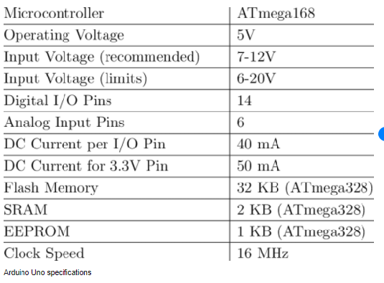

**MQ-8 Gas detecting sensor:**

**Gas Sensor**is the core of the gas detection system and is usually installed in the fraction into

a corresponding electrical signal. The probe uses the gas sensor to adjust the gas sample, which usually includes filtering out impurities and interfering gases, drying or refrigeration treatment, sample pump, and even chemical treatment of the

sample, so that the chemical sensor can make faster measurements. In the following, we'll mainly discuss the properties, typical types, and application fields of gas sensors.

* Operating Voltage is +5V
* Can be used to detect LPG or Butane gas
* Analog output voltage: 0V to 5V
* Digital Output Voltage: 0V or 5V (TTL Logic)
* Preheat duration 20 seconds
* Can be used as a Digital or analog sensor
* The Sensitivity of Digital pin can be varied using the potentiometer

**Buzzer:**

The buzzer is a sounding device that can convert audio signals into sound signals. It is usually powered by DC voltage. It is widely used in alarms, computers, printers and other electronic products as sound devices. It is mainly divided into piezoelectric buzzer and electromagnetic buzzer, represented by the letter "H" or "HA" in the circuit. According to different designs and uses, the buzzer can emit various sounds such as music, siren, buzzer, alarm, and electric bell.

**Relay:**

A Relay is an electromechanical device that can be used to make or break an electrical connection. It consists of a flexible moving mechanical part which can be controlled electronically through an electromagnet, basically, a relay is just like a mechanical switch but you can control it with an electronic signal instead of manually turning it on or off. Again this **working principle of relay**fits only for the electromechanical relay.

**9V battery:**

The **nine-volt battery**, or **9-volt battery**, is a common size of battery that was introduced for early [transistor radios](https://en.wikipedia.org/wiki/Transistor_radio). It has a rectangular prism shape with rounded edges and a polarized snap connector at the top. This type is commonly used in [smoke detectors](https://en.wikipedia.org/wiki/Smoke_detector), [gas detectors](https://en.wikipedia.org/wiki/Gas_detector), [clocks](https://en.wikipedia.org/wiki/Clock), [walkie-talkies](https://en.wikipedia.org/wiki/Walkie-talkie), [electric guitars](https://en.wikipedia.org/wiki/Electric_guitars) and [effects units](https://en.wikipedia.org/wiki/Effects_unit).

**Bread board:**

The bread board has strips of metal which run underneath the board and connect the holes on the top of the board. The metal strips are laid out as shown below. Note that the top and bottom rows of holes are connected horizontally while the remaining holes are connected vertically.

**USB cable:**

The term USB stands for **"Universal Serial Bus"**.  USB cable assemblies are some of the most popular cable types available, **used mostly to connect computers to peripheral devices** such as cameras, camcorders, printers, scanners, and more. Devices manufactured to the current USB Revision 3.0 specification are backward compatible with version 1.1.

**Exhaust fan:**

This Brushless DC Cooling Fans are operating at 12V with a dimension of 80x80mm. They are typically found in ATX Computer cases, servers, and other enclosed equipment but they can also be used in a variety of other projects requiring moderate airflow. The fan spins at ~2600 RPM and can move approximately 30CFM. It is fairly quiet – just 30.7dBA. There are two connectors commonly found in PCs on the end – a 4 pin Molex connector designed to fit inline with older style hard drive connectors and a smaller 3 pin Molex KK 2.54mm that is compatible with our 3 pin Molex Header. To use the fan, simply connect Red to 12V, Black to Ground. The White wire is a Tach signal – it can be used to monitor the fan rotation or left disconnected if it isn’t needed.

**Jumper wires:**

A **jump wire** (also known as **jumper**, **jumper wire**, **DuPont wire**) is an [electrical wire](https://en.wikipedia.org/wiki/Electrical_wire), or group of them in a cable, with a connector or pin at each end (or sometimes without them – simply "tinned"), which is normally used to interconnect the components of a [breadboard](https://en.wikipedia.org/wiki/Breadboard) or other prototype or test circuit, internally or with other equipment or components, without soldering.[[1]](https://en.wikipedia.org/wiki/Jump_wire#cite_note-1)

Individual jump wires are fitted by inserting their "end connectors" into the slots provided in a breadboard, the [header connector](https://en.wikipedia.org/wiki/Pin_header#Header_connector) of a circuit board, or a piece of test equipment.

**BLOCK DIAGRAM**

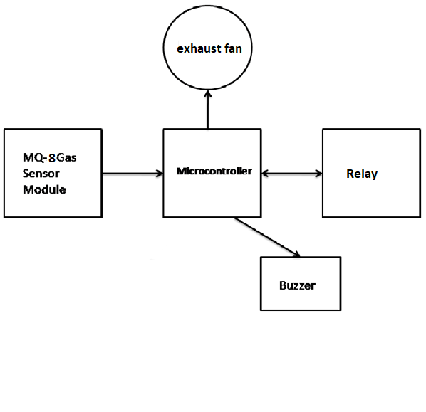

**RESULT AND DISCUSSION:**

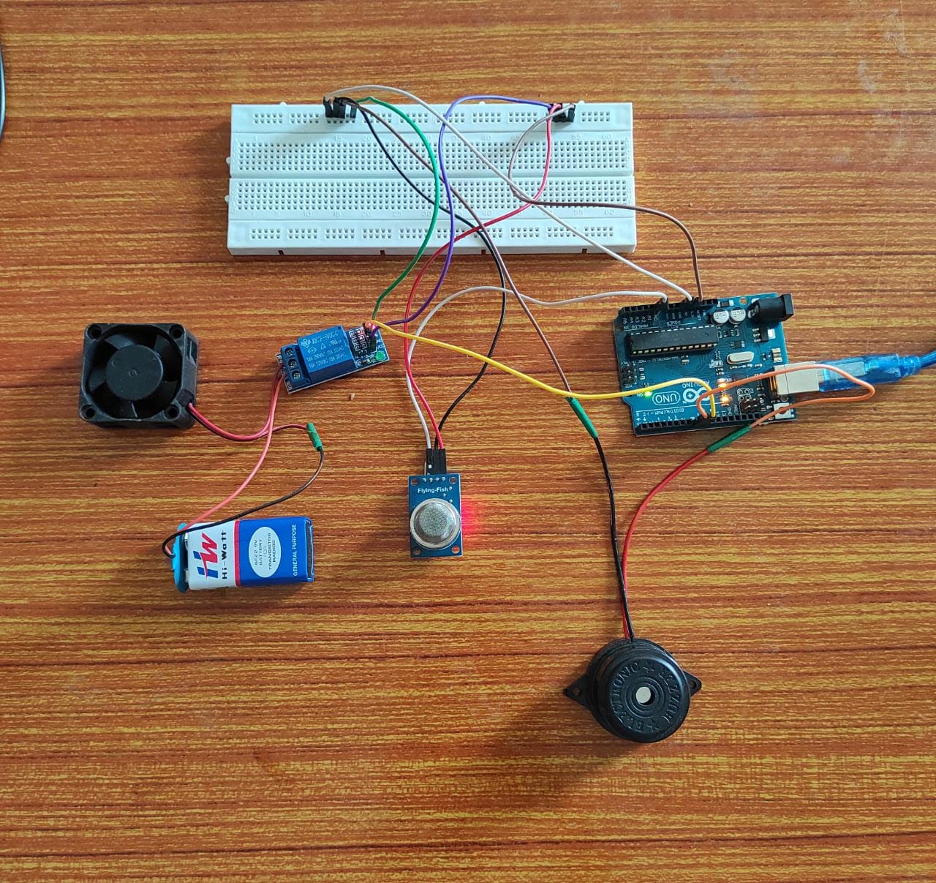

**DISCUSSION:**

When the gas leak is detected exhaust fan is switched on the first mention method has the disadvantage that there is no control action taken it needs a manual controlling which puts human into direct risk the second method has the disadvantage that if the wiring of the exhaust fan is not proper then it will cause immediate explosion due to the flow of AC in all these mentioned methods above there is only detection no control action is taken another method is also been employed

Which involves detecting as well as controlling of the LPG leakage this process starts from the gas leakage

Provided for alerting the neighbours in case of the absence of the user about the LPG gas uses the name of the system is to reduce the probability of explosion due to gas leak case the main advantage of the system is that it does all the process automatically and has a quick response

Generally semiconductor sensor are asked to detect LPG gas mq-8 semiconductor sensor used in this project sensitive material of MQ8 gas sensor is serial number to which with lower conductivity in clean air in the target combustible gas exist the sensor conductivity increases along with the rising gas concentration intuit gas sensor has high security to propane butane and LPG gas

Also respond to natural gas the sensor could be used to detect different combustible gases especially methane it is with low cost and suitable for different application the imperial gas sensor can get a gas concentrations anywhere from 200 to 1000 PPM the sensor output is an analogue resistance

The mq8 gas sensor module detect the various gases like probin isovue in LPG it will detect and send to AVR microcontroller controller will check whether the sensor is detected or not It is detected the alarm will be on as well as GSM module is connected to the AVR microcontroller is ASM device provided that are linked to a remote network and when the alarm is on the exhaust fan also rotate when the LPG gas leakage sends it will give a hypothesis on its 2 pin and ordinal constantly reads its open when order no receives the high pulse from the LPG gas sensor module in displays the LPG gas leakage alert when order now gets low pulse from the LPG gas detector module then it will show the no LPG gas leakage alert by the sound of the buzzer alarm you can understand that the certain gas is detected and it will it is over to live what is the complete process of the system like reading LPG gas sensor module output which can set the sensitivity of the sensor model by inbuilt potentiometer located LPG gas sensor module analogue output pin is directly connected to the pin of order no and vcc and ground are connected to leases and ground LPG gas sensor consists MQ8 sensor which detects LPG gas and other gases also like Pro 10 ISO group u10 is m28 gas sensor has a l inside which needs some heat are supplied to heat up and it may take up to 1 minute to get ready for detecting LPG gas and comparator circuit is used for converting analogue output of a right in digital when the mq8 gas sensor detects the gas then the gas sensor activates the buzzer alarm turn on and the rotates the exhaust fan they also require jumper wires and 9 volt battery and breadboard and the power supply for the whole connections to sense the gas.

**WORKING:**

The Proteus Design Suite is a proprietary software tool suite used primarily for electronic design automation. The software is used mainly by electronic design engineers and technicians to create schematics and electronic prints for manufacturing printed circuit boards. Figure 3 shows the circuit diagram that was designed using Proteus libraries.

This system is based on Arduino UNO R3 and MQ-6 gas sensor. When the sensor detects gas in atmosphere, it will give a digital output of 1 and if gas is not detected the sensor will give a digital output of 0. Arduino will take the sensor output as the digital input. If sensor output is high, then the buzzer will start tuning and the exaust fan will turn on.

If sensor output is low then the buzzer will not be tuning, ans the exhaust fan will not turn on. The detector incorporates a MQ-6 sensor (with gas detection range of 300–10,000 ppm) as the LPG gas sensor, PIC16F690 microcontroller as the control unit, a buzzer as an alarm The microcontroller senses the presence of a gas when the voltages signal from the MQ-6 sensor goes beyond a certain level and gives an audio alarm.

If the system detects the level of gas in the air that exceeds the safety level it will activate the alarm which includes the buzzer to alert the users at home of the abnormal condition and to take any necessary action. The most tell-tale sign of a leak is the smell of gas in the home. This is an efficient method for automatically detecting and controlling the gas leakage. Moreover, the fire accidents are also prevented by switching off the power supply.

The idea for gas detection and control can be implemented at a large scale for various industries. This system can be installed in a kitchen, at a hostel cafeteria, and any other areas. This can be helpful in reducing accidents caused by gas household as well as in any similar commercial set up. In our country there are 180 million people, and due to its low cost this product is affordable and will prevent many accidents and save many properties and human lives.

**APPLICATIONS:**

In the kitchen, gas sensors are used to detect the **gas leak** such as natural gas, liquefied petroleum gas and city gas, and automatically controlling the microwave by detecting the gas generated by the food cooked in the microwave oven

Carbon dioxide sensors, smoke sensors, ozone sensors, etc. used in houses, buildings, conference rooms, and public places for entertainment, and gas sensors used to control the automatic operation of air purifiers or electric fans

In some high buildings, gas sensors can also be used to detect fire signs and call the police.

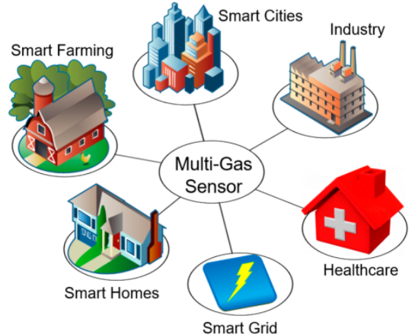

**ADVANTAGES:**

* Get real-time alerts about the gaseous presence in the atmosphere
* Prevent fire hazards and explosions
* Supervise gas concentration levels
* Ensure worker’s health
* Real-time updates about leakages
* Cost-effective installation
* Data analytics for improved decisions
* Measure oxygen level accuracy
* Get immediate gas leak alerts

**DISADVANTAGES:**

* It requires oxygen to work.
* It can be poisoned by lead, chlorine and silicon
* Very sensitive to extreme environmental changes.
* It works only when 5v power supply is given.
* Its sensitivity depends on humidity and temperature
* Takes time to respond when gas leakage detected is more

**CONCLUSION**

The design of a sensor-based automatic gas leakage detector with an alert and control system has been proposed and discussed in this paper. This is a low-cost, low power, lightweight, portable, safe, user friendly, efficient, multi featured and simple system device for detecting gas. Gas leakage detection will not only provide us with significance in the health department but it will also lead to raise our economy, because when gas leaks it not only contaminates the atmosphere but also wastage of gases will hurt our economy. The proposed system will cost only USD 10 which is easily affordable even for poor people. In the open literatures it is noticed that much work has not been done for a smart gas detection system. In future, more advanced features will be integrated with this system which will provide users with more safety and relaxation. The proliferation of handheld devices has led to developments in the field of smart gas sensors, which has considerably widened their scope of application. The need for ensuring safety in workplaces is expected to be the key driving force for the market over the coming years.

**FUTURE SCOPE**

Overall, software and hardware parts of the systems have been developed and tested by introducing a small amount of LPG near gas sensor module

One of the notable future functions of this system is to add a sub system where wastage of gas and the uses of gas can be monitored using this system. The system is flexible as a greater number of sensors and relays can be added to it according to the whole LPG supply setup in those premises.

This is an automatic gas detection, control and alert system. In future this system will have a feature

The overall features will make the system more safe for the users.

. The system will be optimized for use in many places like the car, the home, industries and many other places. After designing the final prototype with smart multifunctional features, the system will be implemented in real life scenarios as a pilot project

**REFERENCES**

* [**https://innovativeideasyoutube.blogspot.com/**](https://innovativeideasyoutube.blogspot.com/)
* [**https://www.igi-global.com/**](https://www.igi-global.com/)
* [**https://ieeexplore.ieee.org/**](https://ieeexplore.ieee.org/)
* **https://en.wikipedia.org/**

**PHOTOS OF WORKING PROTOTYPES AT DIFFERENT STAGES**

**Before giving power supply:**

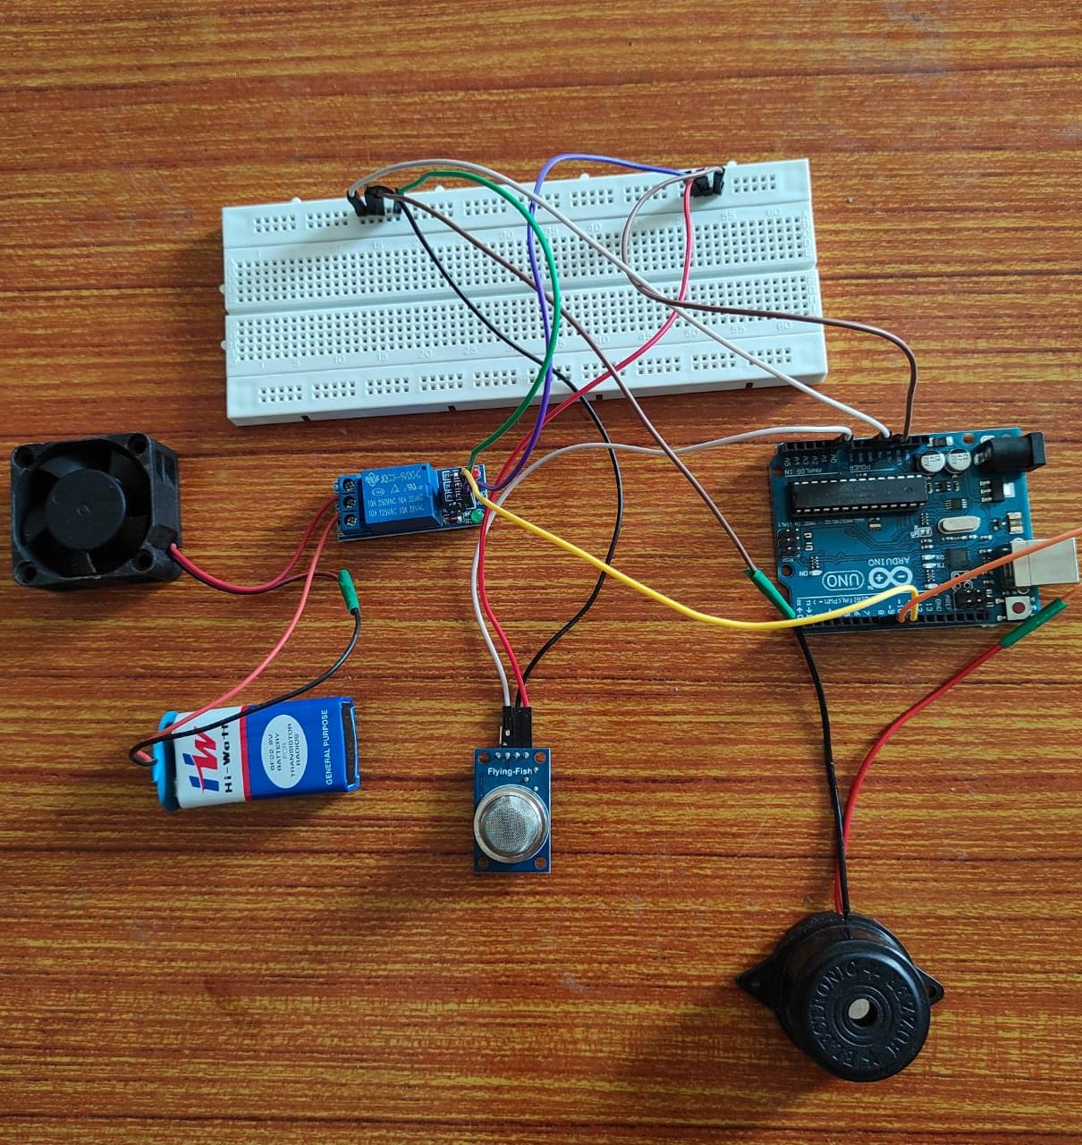

**After giving power supply:**



**After leaking of gas:**

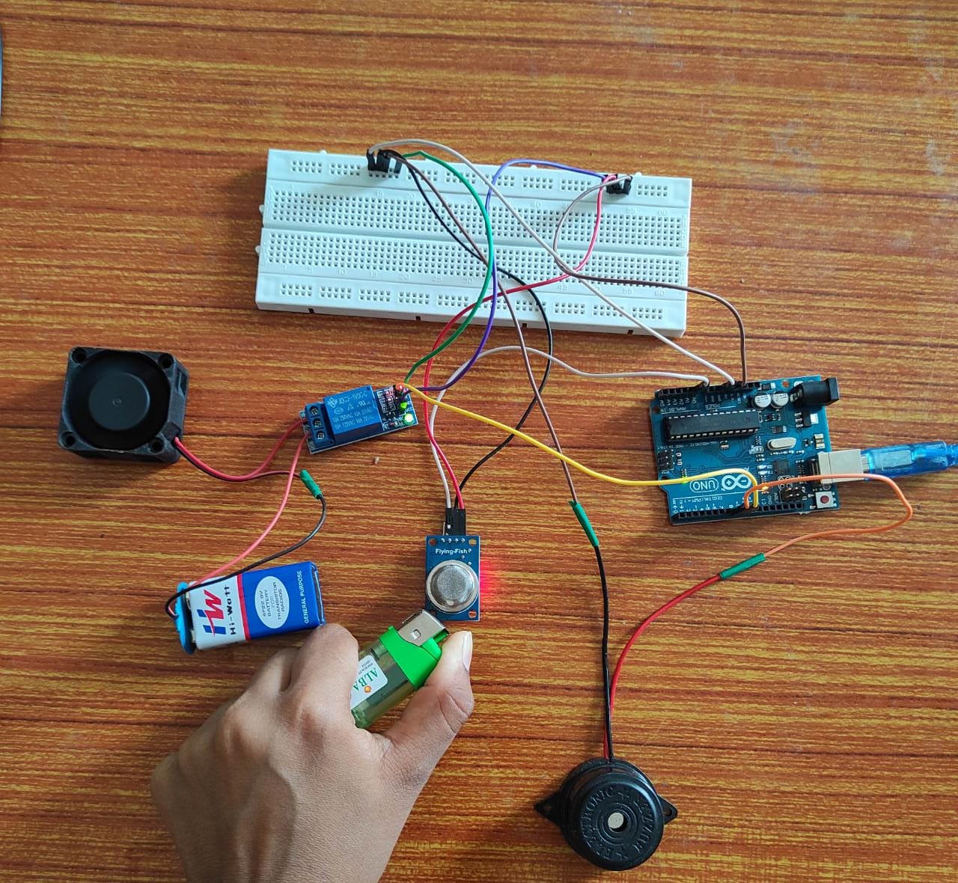

**WORKING CODES**

#define Sensor pin = A0;

#define relay pin = D9;

#define Buzzer Pin = D8;

#define sensorDigital A0;

#define relay 9;

#define buzzer 8;

#define sensorAnalog A1;

void setup()

{

#define Sensor pin = A0;

#define relay pin = D9;

#define Buzzer Pin = D8;

#define sensorDigital A0;

#define relay 9;

#define buzzer 8;

pinMode(sensorDigital, INPUT);

pinMode(relay, OUTPUT);

pinMode(buzzer, OUTPUT);

Serial.begin(9600);

}

void loop() {

bool digital = digitalRead(sensorDigital);

int analog = analogRead(sensorAnalog);

Serial.print("Analog value : ");

Serial.print(analog);

Serial.print("t");

Serial.print("Digital value :");

Serial.println(digital);

if (digital == 0) {

digitalWrite(relay, LOW);

digitalWrite(buzzer, HIGH);

delay(5000);

digitalWrite(relay, HIGH);

digitalWrite(buzzer, LOW);

}

else

{

digitalWrite(relay, HIGH);

digitalWrite(buzzer, LOW);

}

**}**